1.Git Hands-on

Familiar with Git commands like git init, git status, git add, git commit, git push, and git pull.

In this hands-on lab, you will learn how to

* Setup your machine with Git Configuration

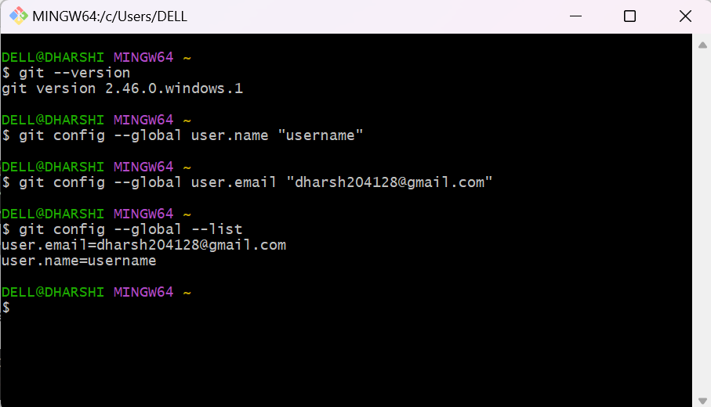

* Integrate notepad++.exe to Git and make it a default editor

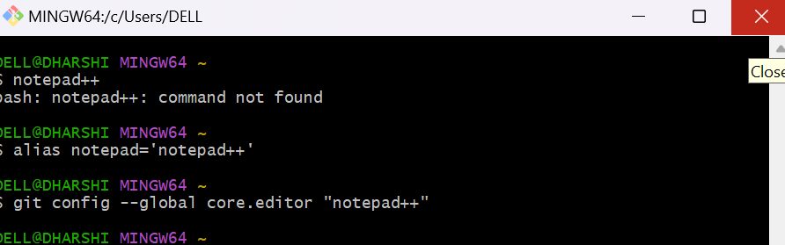

* Add a file to source code repository\

